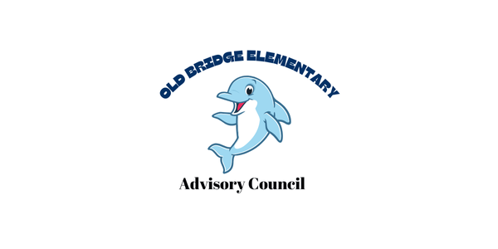

Minutes
Date: February 5, 2025
Time: 5:00 pm
Attendance
- Principal Alyssa Francisco | - Lisa Haight
- Assistant Principal Lisa Jackson | - Meghan Maldonado
- Brenda Garces | - Anna Beck
- Magally Hurtado | - Carolina Serrano
- Trainee Knotts
CIP update:
· Learning & Achievement for ALL
- 1st Grade VALLS - 89% OGL- 14% increase from the fall
- 2nd Grade VALLS - 89% OGL- 7% increase from the fall
- 3rd Grade Mat VGA - 17% increase OGL
- 4th Grade Mat VGA – 11 decrease OGL
- 5th Grade Math VGA – 10% increase OGL
· HMH Growth:
- 3rd Grade HMH Growth – 72% OGL – 21% increase from the fall
- 4th Grade HMH VGA – 72% OGL – 4.3% increase from the fall
- 5th Grade HMH Growth – 75% OGL – 23.6% increase in terms of AGL
. Chronic Absenteeism
- Reduce chronic absenteeism to 5% or less by the end of the 2025 school year.
- Currently we are at 9.11%
Budget Update:
Secured additional support for third grade classrooms.
Priorities for Next year
- Additional 4th grade teacher
- Additional LD Teacher
- Consider ELL Numbers
PTO Update
Information on several events coming up that support the enrichment for our students
- Paint Night
- Movie Night
- Sock Hop

