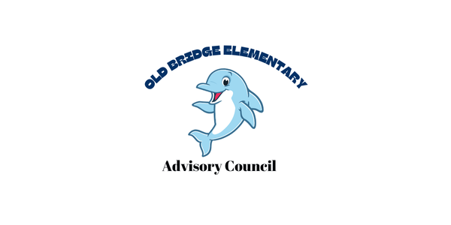

Minutes
Date: September 4, 2024
Time: 5:00 pm
Attendance
- Principal Alyssa Francisco
- Assistant Principal Lisa Jackson
- Brenda Garces
- Magally Hurtado
- Maryan Castle
- Elizabeth Arrington Jones
- Lisa Haight
- Meghan Maldonado
- Anna Beck
- Carolina Serrano
- LeAnne Hendricks
- Megan Everett

Bylaws
Revision of the bylaw (posted on the website)
CIP update:
3 strategic priorities/Impact Goals
- 30% of students in grades 3-5 will score Pass Advance on the reading SOL assessment. (Last year 25%)
- 30% of students in grades 3-5 will score 90% or higher every 4 weeks on vertically aligned monthly power assessments.
- 100% of K-3 students identified in the moderate & high risk bands of VALLSS will have positive movement toward the low risk band

Implement:
- 100% of K-5 teachers will use high quality instruction materials for delivery in all aspects of the literacy block
- 100% of 3-5 teachers will discuss student results on the assessments and implement actionable next steps to meet all students’ individual needs
- 100% of students in grades K-5 will develop individualized learning goals to promote their progress and assume responsibility for their growth
Positive climate and culture
- Reduce chronic absenteeism to 5% or less by the end of the 2025 school year.
- Last year we went from 16% to 9%.
- Attendance plan developed with families
- Incentive program
Family and Community Engagement
- Old Bridge will have a high functioning advisory council by the end of SY25 by scoring at least 16/20 (80%) on the Advisory rubric.
Budget:
- Reviewed Fixed and Per Pupil allocations.
- Properly staffed for the opening of the 2024-2025 academic school year.
PTO Update
Boosterthon Kickoff 10/09
News!
Principal Alyssa Francisco has been chosen to be part of the Superintendent Principal Advisory Council

